Brazuela



|  |
| --- |
| August 18th 2017 |

Iron Man: The Clone Attack

Version 3.0

All work Copyright © by Brazuela

All rights reserved.

Renato Carneiro

Kenny Perroni

Table of Contents

[I. Game Overview 4](#_Toc490838612)

[II. Game Play Mechanics 5](#_Toc490838613)

[III. Camera 7](#_Toc490838614)

[IV. Controls 8](#_Toc490838615)

[V. Interface Sketch 9](#_Toc490838616)

[VI. Menu and Screen Descriptions 10](#_Toc490838617)

[VII. Game World 11](#_Toc490838618)

[VIII. Levels 12](#_Toc490838619)

[IX. Game Progression 15](#_Toc490838620)

[X. Characters 16](#_Toc490838621)

[XI. Enemies 17](#_Toc490838622)

[XII. Weapons 18](#_Toc490838623)

[XIII. Items 19](#_Toc490838624)

[XIV. Abilities 20](#_Toc490838625)

[XV. Script 21](#_Toc490838626)

[XVI. SCORING 22](#_Toc490838627)

[XVII. Sound Index 24](#_Toc490838628)

[XVIII. Story Index 25](#_Toc490838629)

[XIX. Art / Multimedia Index 26](#_Toc490838630)

[XX. Future Features 33](#_Toc490838631)

Version History

Iron man: the clone attack v1.0: First version of the document. It contains the principal aspects of the game and basic concepts.

IRON MAN: the clone attack v2.0: second version of the document. It contains new aspects and features. Also, it expands and improves v1.0 characteristics.

IRON MAN: the clone attack v3.0: third version of the document. IT REFINES DETAILS, AND it ADDS NEW ENEMIES, LEVELS, AND ACTIONS.

# Game Overview

After a disastrous experiment with Bruce Banner, Tony Stark finds himself in a forsaken basement in his own manor. While thinking who could have sabotaged his anti-radiation chamber, he was already surrounded by countless of cloned Hulks.

Join Iron Man’s quest to help his friend Bruce Banner and find the culprit that has caused such mayhem that could destroy Iron Man and the city for good.

Are you strong enough to survive the wrath of an army of Hulks? Can you find the mastermind behind this disaster?

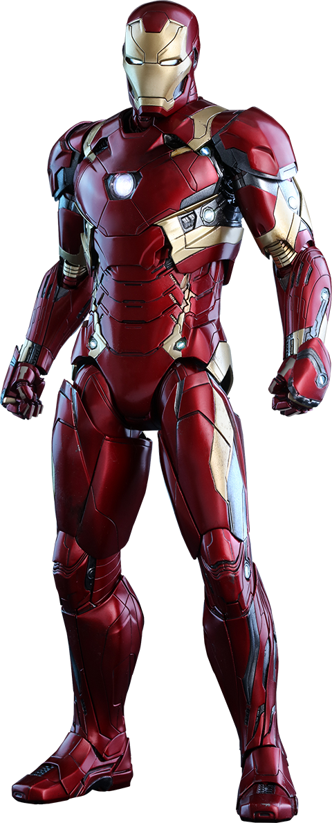

# Game Play Mechanics

The player controls Tony Stark in his Iron Man suit. Iron Man can perform the following actions:

* Walk left or right

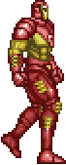

Walking animation

* Fly up and Down. While flying, iron man can avoid obstacles and foes

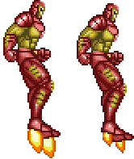

Flying animation

* SHOOT PROJECTILES TO KILL HIS ENEMIES

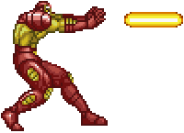

Shooting animation

* Punch to kill his enemies

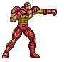

Punch animation

# Camera

The camera for this game is a side-scroller.

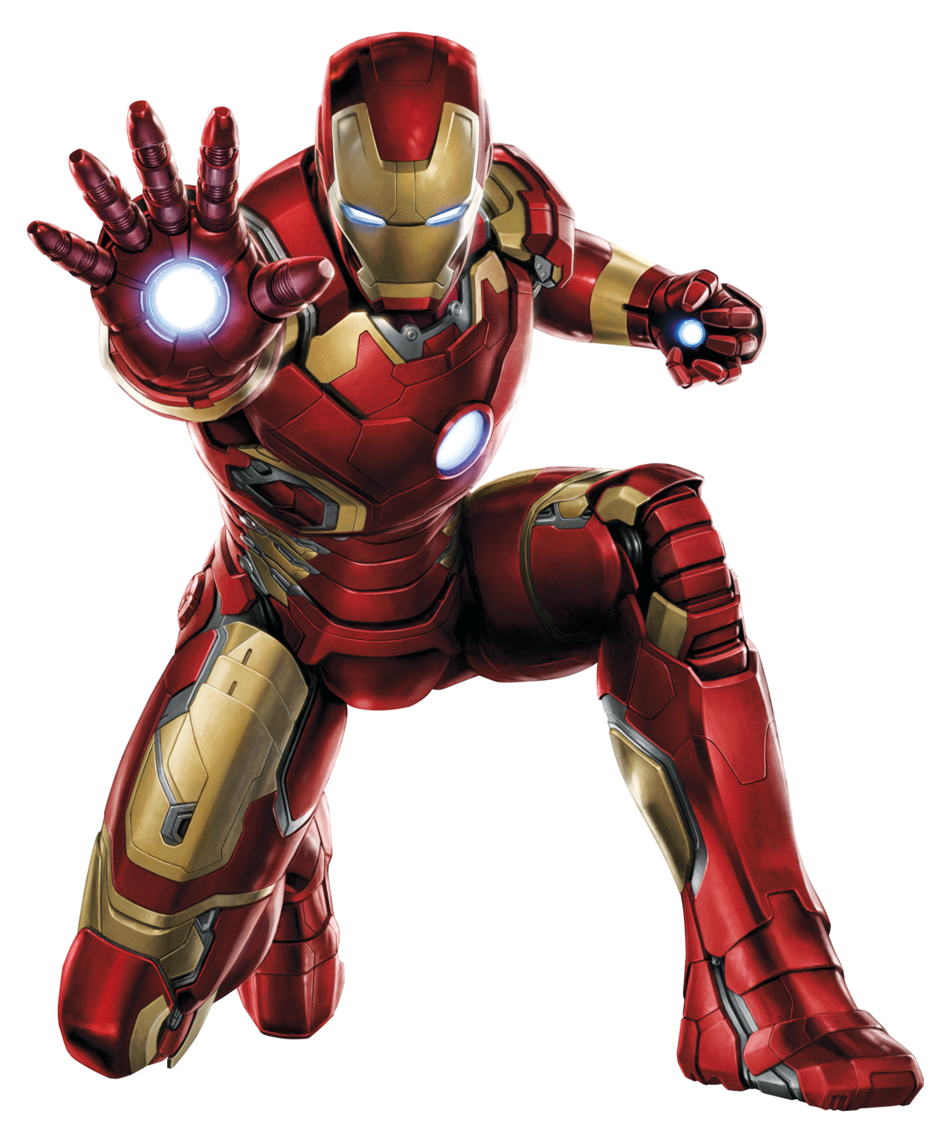

# Controls

The keyboard is needed in order to play this game.

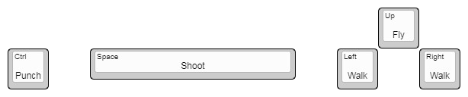



# Interface Sketch

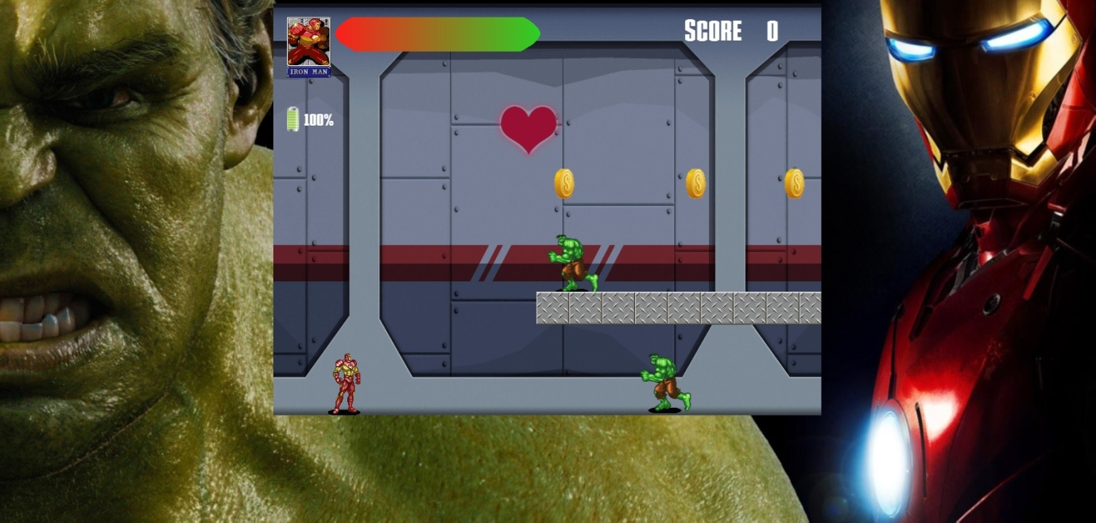The game interface is represented in the image below:

FIRST LEVEL OF THE GAME

# Menu and Screen Descriptions

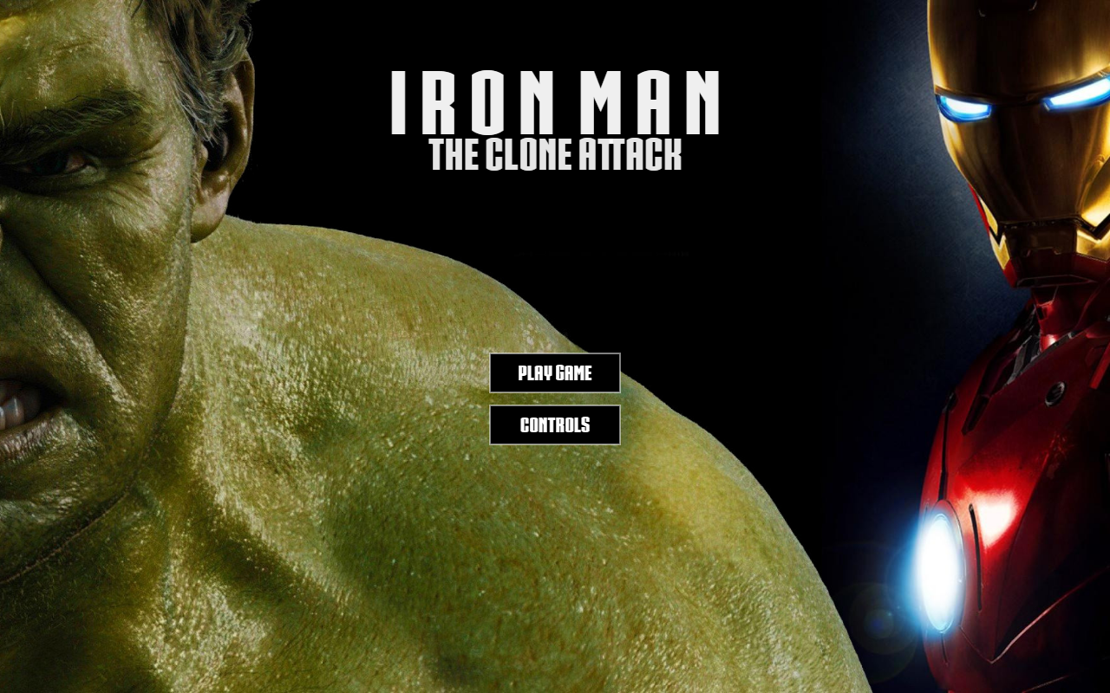Main Menu in which you can choose to play the game or look at the controls

# Game World

The game world contemplates Tony Stark’s manor. Iron Man has to make his way up to the lab passing through 3 different levels: basement, storage room, and laboratory.

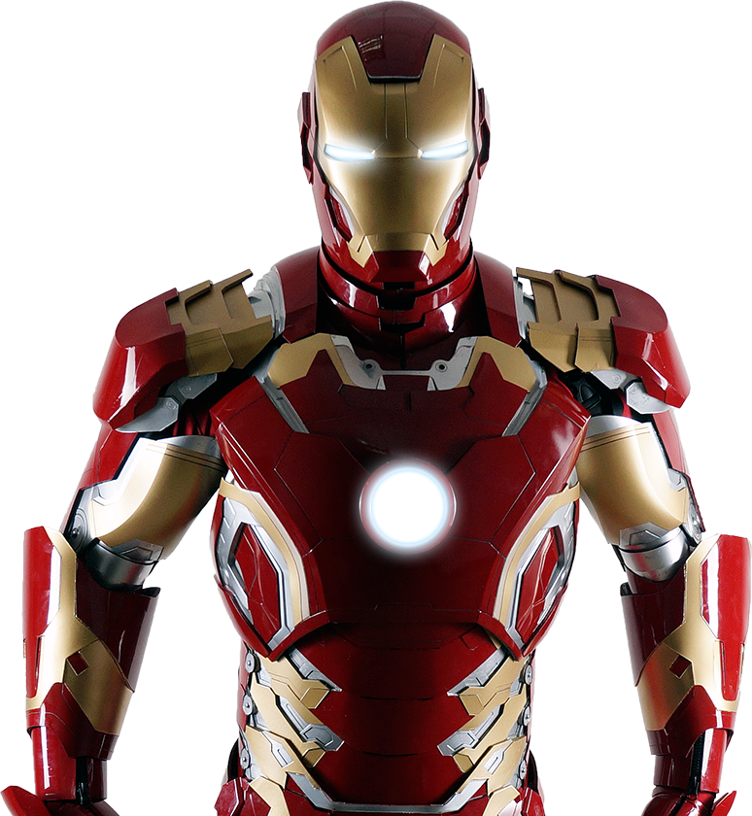

# Levels

* Level 1:

This level is a secret basement that contains abandoned projects created by Tony Stark. This level is infested with hulks and contains platforms.

first level of the game

* Level 2:

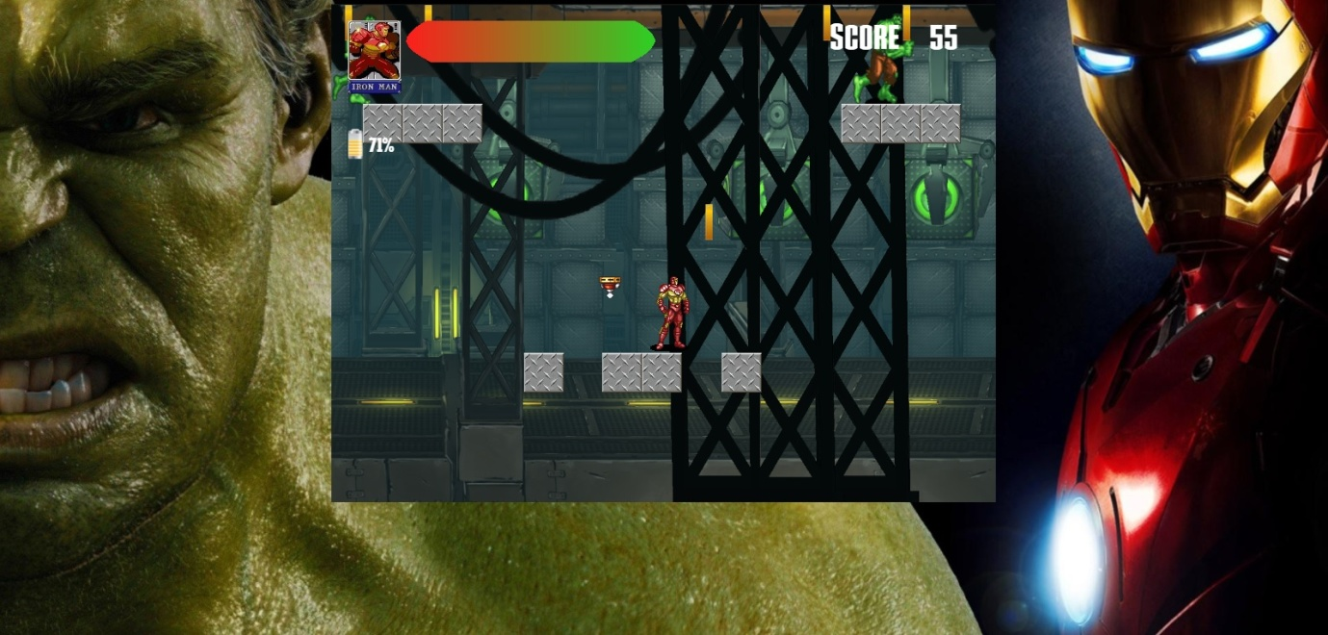This level is a storage room above the basement; it contains Tony Stark’s first prototypes of machines AND EXPERIEMNTS.IN THIS LEVEL, THE CLONED HULKS DO MORE DAMAGE THANKS TO A PROTEIN THAT THEY FOUND IN THIS STAGE; THEREFORE THEY ARE BIGGER THAN THE ONES IN THE FIRST LEVEL. Also, weak flying robots can be found.

Second level of the game

* Level 3:

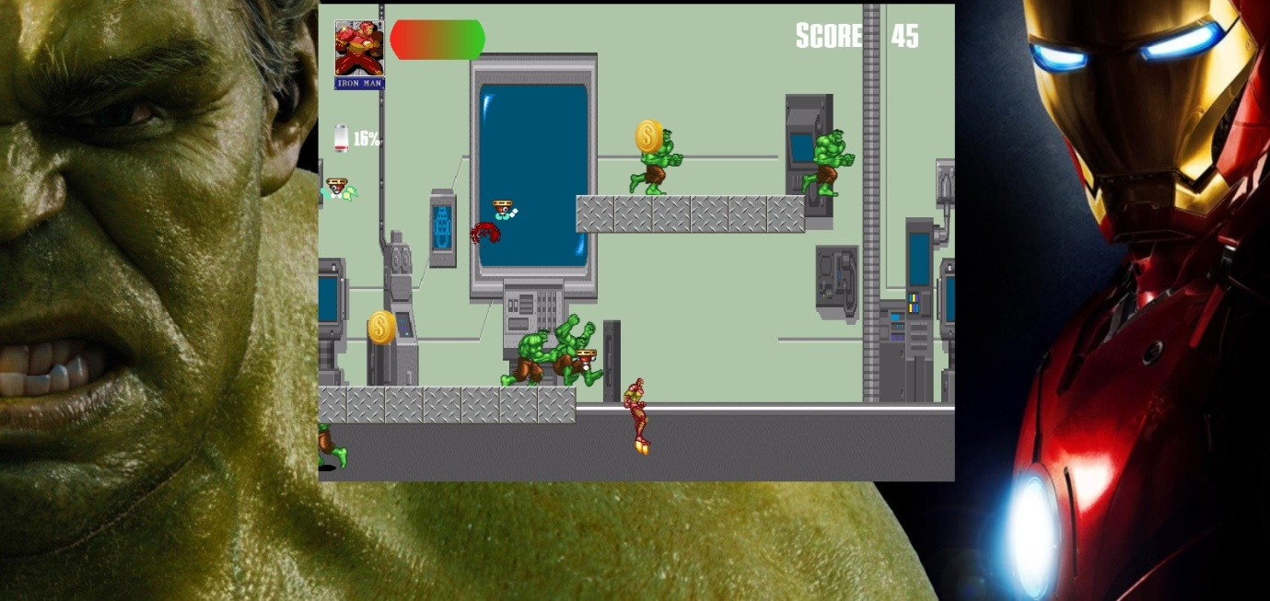This level is the laboratory where the accident happened; it contains computers and robots. In this level, the cloned hulks manipulated the flying robots, so they now do more damage when they explode when they hit iron man.

Third level of the game

# Game Progression

In order to complete a level, the player needs to reach the door to the next stage while fighting or evading Hulk’s clones. There are 3 levels in total; they have different layouts and obstacles that the player needs to overcome. When the player completes all the 3 levels, the player wins, and the game is over.

**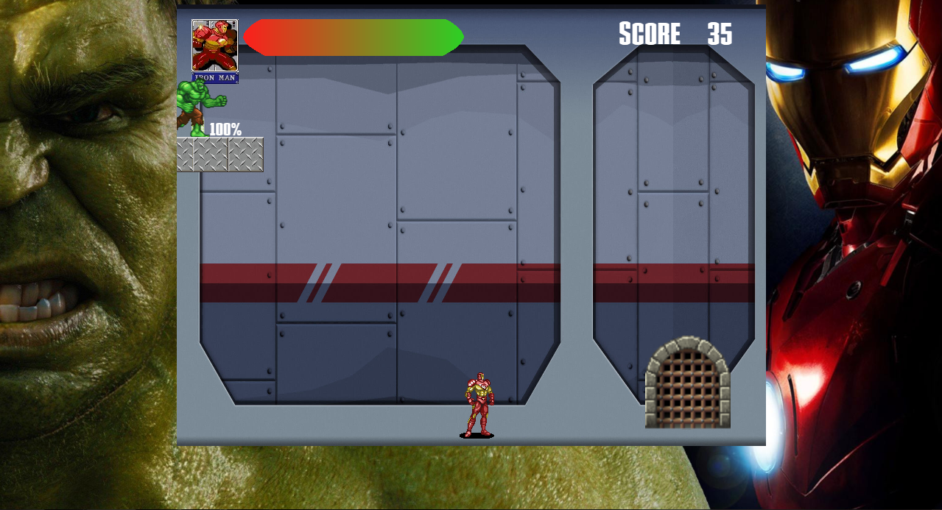**Door to the next level

# Characters

The avatar of the game is Iron Man. Behind that heavy armor stands the multi-billionaire and the genius who created several Iron Man suits whose name is Tony Stark. Even though he has alcoholic problems, he has overcome his difficulties and used his powers to become one of the greatest Marvel’s super heroes.

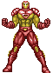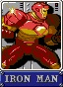

Iron man avatar

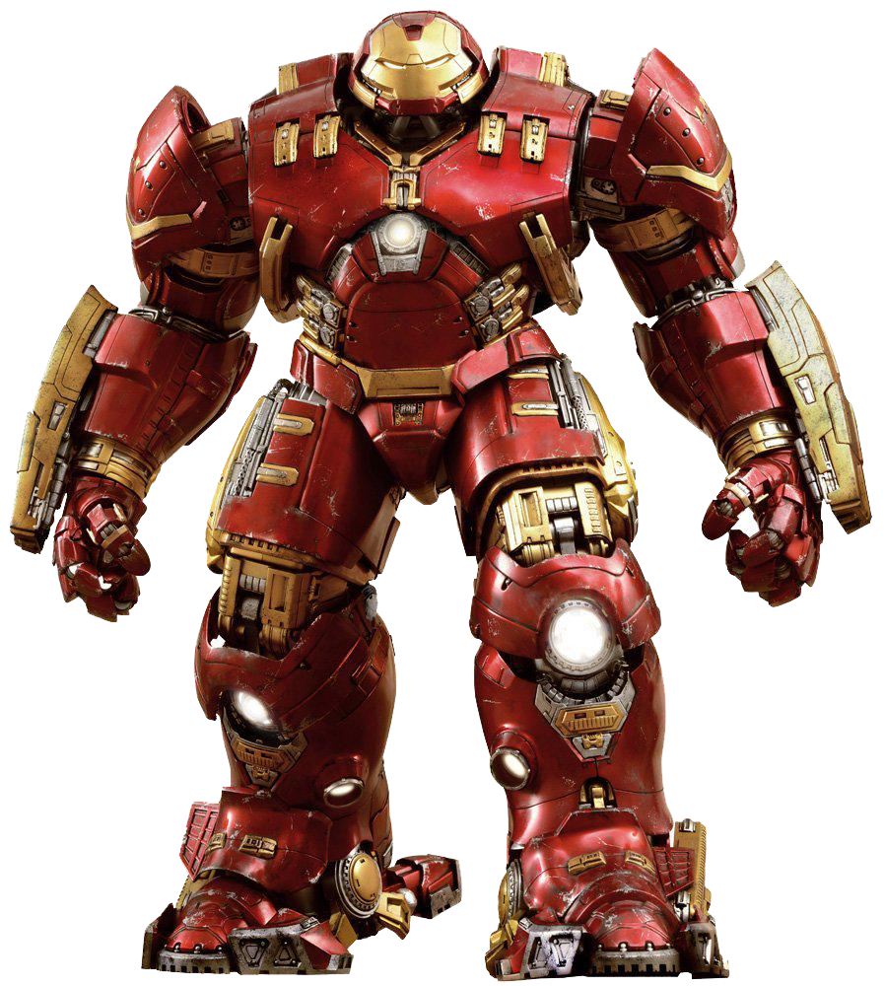

# Enemies

Hulk: the cloned Hulks are the main enemy caused by the accident in the lab. They attack iron man if they are close to him. Each attack will decrease iron man’s health. As the game progresses, they become more powerful when they punch iron man.

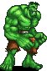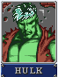

HULK ENEMY iron man health bar

Flying robots: they start appearing on level 2. They are abandoned prototypes that tony stark created but did not finish. As the game progresses, they become more powerful when they explode near iron man.



Flying enemy

# Weapons

Iron Man has a laser that he shoots through his hands. It is a powerful projectile that can neutralize his enemies with one blow; however, he spends energy when he uses this attack.



IRON MAN SHOOTING LASER PROJECTILE Energy meter

# Items

COINS: THEY ARE SCATTERED THROUGH THE DIFFERENT LEVELS. WHEN IRON MAN COLLECTS ONE, THE PLAYER SCORES 5 POINTS.



coins

HEARTS: THIS POWER-UP CAN BE FOUND ON DIFFERENT LEVELS; HOWEVER, THEY ARE NOT TOO MANY. WHEN IRON MAN COLLECTS A HEART, HE HEALS 3 POINTS.

Hearts

# Abilities

Thanks to his super suit, Iron Man is able to fly; however, he spends energy when performs this action.





IRON MAN FLYING ABILITY Energy meter

# C:\dev\masters\beg-html5-games-w-createjs-master\9781430263401_source_code\Ironman--The-Clone-Attack\extraFiles\Prints\Classe diagram.jpgScript

Script and classes

# SCORING

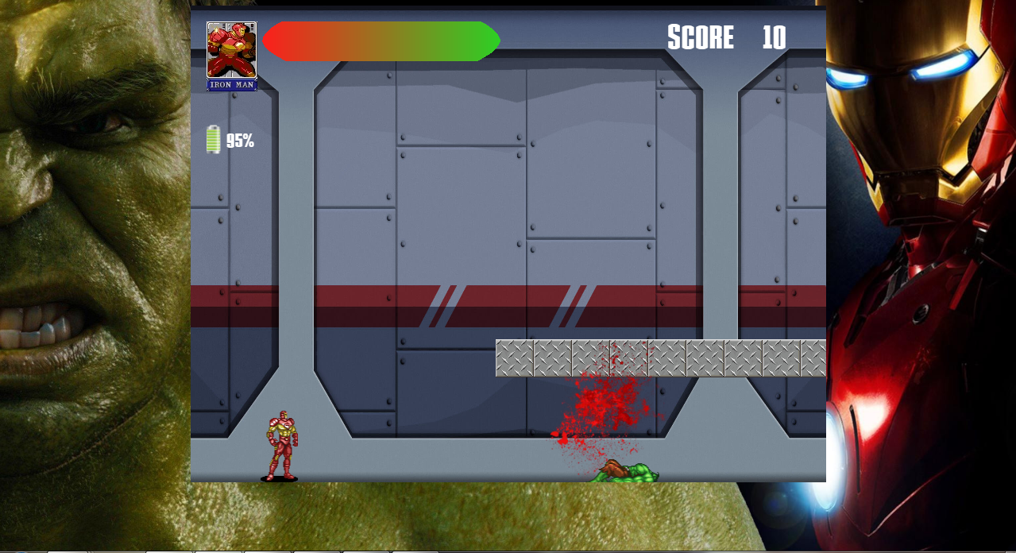EACH TIME THAT IRON MAN KILLS A CLONED HULK, THE PLAYER WILL get TEN POINTS

Iron man scoring points by killing hulks

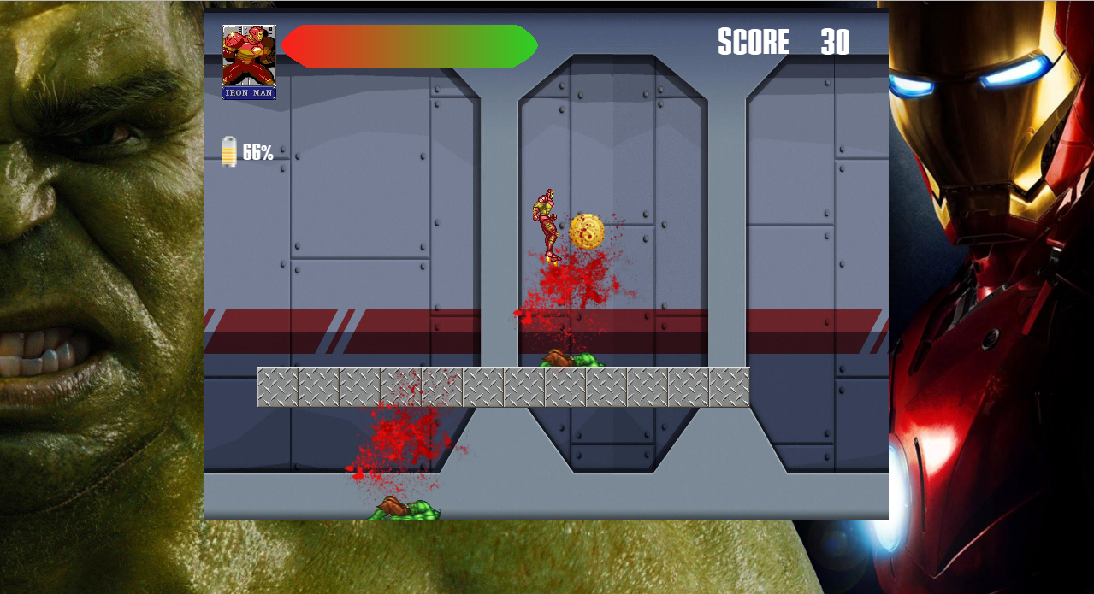Also, iron man can find coins while navigating through the levels. When he collects a coin, the player scores 5 points.

Iron man scoring points by colleting coins

# Sound Index

* Intro – plays when the main menu is shown
* Level 1 – Plays when the player clicks on the “play game” button in the game menu, which starts level 1
* Level 2 – plays when the player starts level 2
* Level 3 – plays when the player starts level 3
* Jet – Plays when Iron Man flies
* Laser – Plays when Iron Man shoots projectiles
* Punch – plays when iron man gets hit by a hulk punch or when iron man hits a hulk with his punch
* Explosion – plays when a flying enemy hits iron man
* Restore hp – plays when iron man collects a heart
* Death – plays when iron man loses all his hitpoints
* Cash – plays when iron man collects coins
* Hulk – plays when the “play game” button is clicked
* Win – plays when the player completes level 3
* Game over music – plays a music when the gamer over screen is prompted
* Game over voice – plays a voice when the game over screen is prompted

# Story Index

Tony Stark was working in his laboratory trying to find a cure for Bruce Banner’s radiation that drives him to become the Hulk. After long days and nights, he finally created an anti-radiation chamber fully capable of doing the job. Bruce Banner arrived at Tony’s laboratory with high expectations and ready to be released from his torment. He entered the chamber, and Tony started the machine. It seemed like Bruce Banner was going to be a common human being again, but something went deadly wrong.

While inside the chamber, Bruce Banner started cloning himself countless times. Tony struggled to stop it, but in his effort, he caused an explosion that blew up the entire laboratory. Tony and countless clones of Bruce fell down to a secret basement in the Stark’s manor. As soon as Tony regained consciousness, he saw 10 Hulks surrounding him ready to destroy him. Luckily, his Iron man suit took him away from them.

Tony was sure that the chamber was perfect, so he knew that someone had sabotaged it, but who?

Join Iron man in his epic battle against an army of Hulks in order to save his friend Bruce Banner. Can you stand the fury of thousands of Hulks? Can you find the villain behind this chaos?

# Art / Multimedia Index

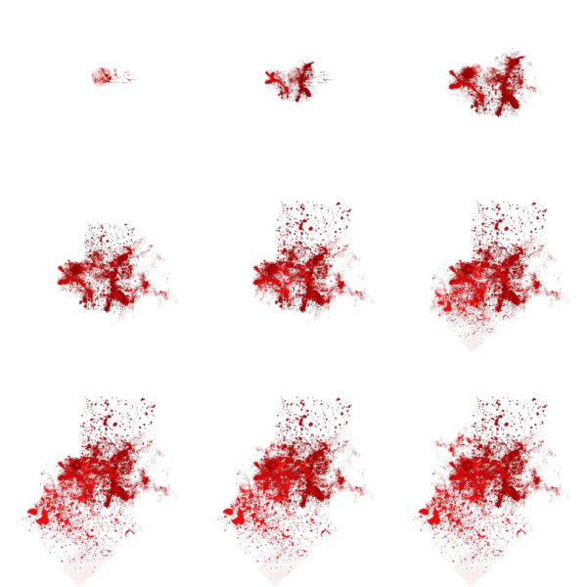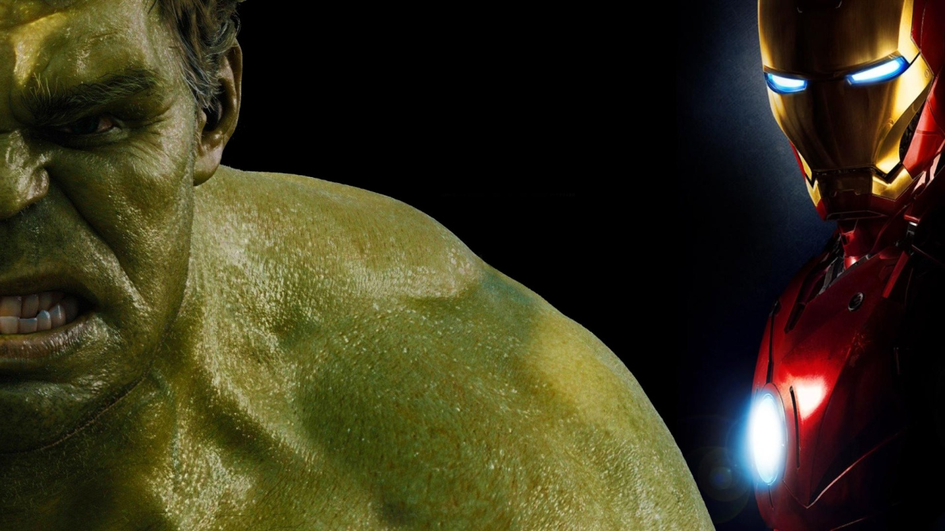Game Background

Blood sprite

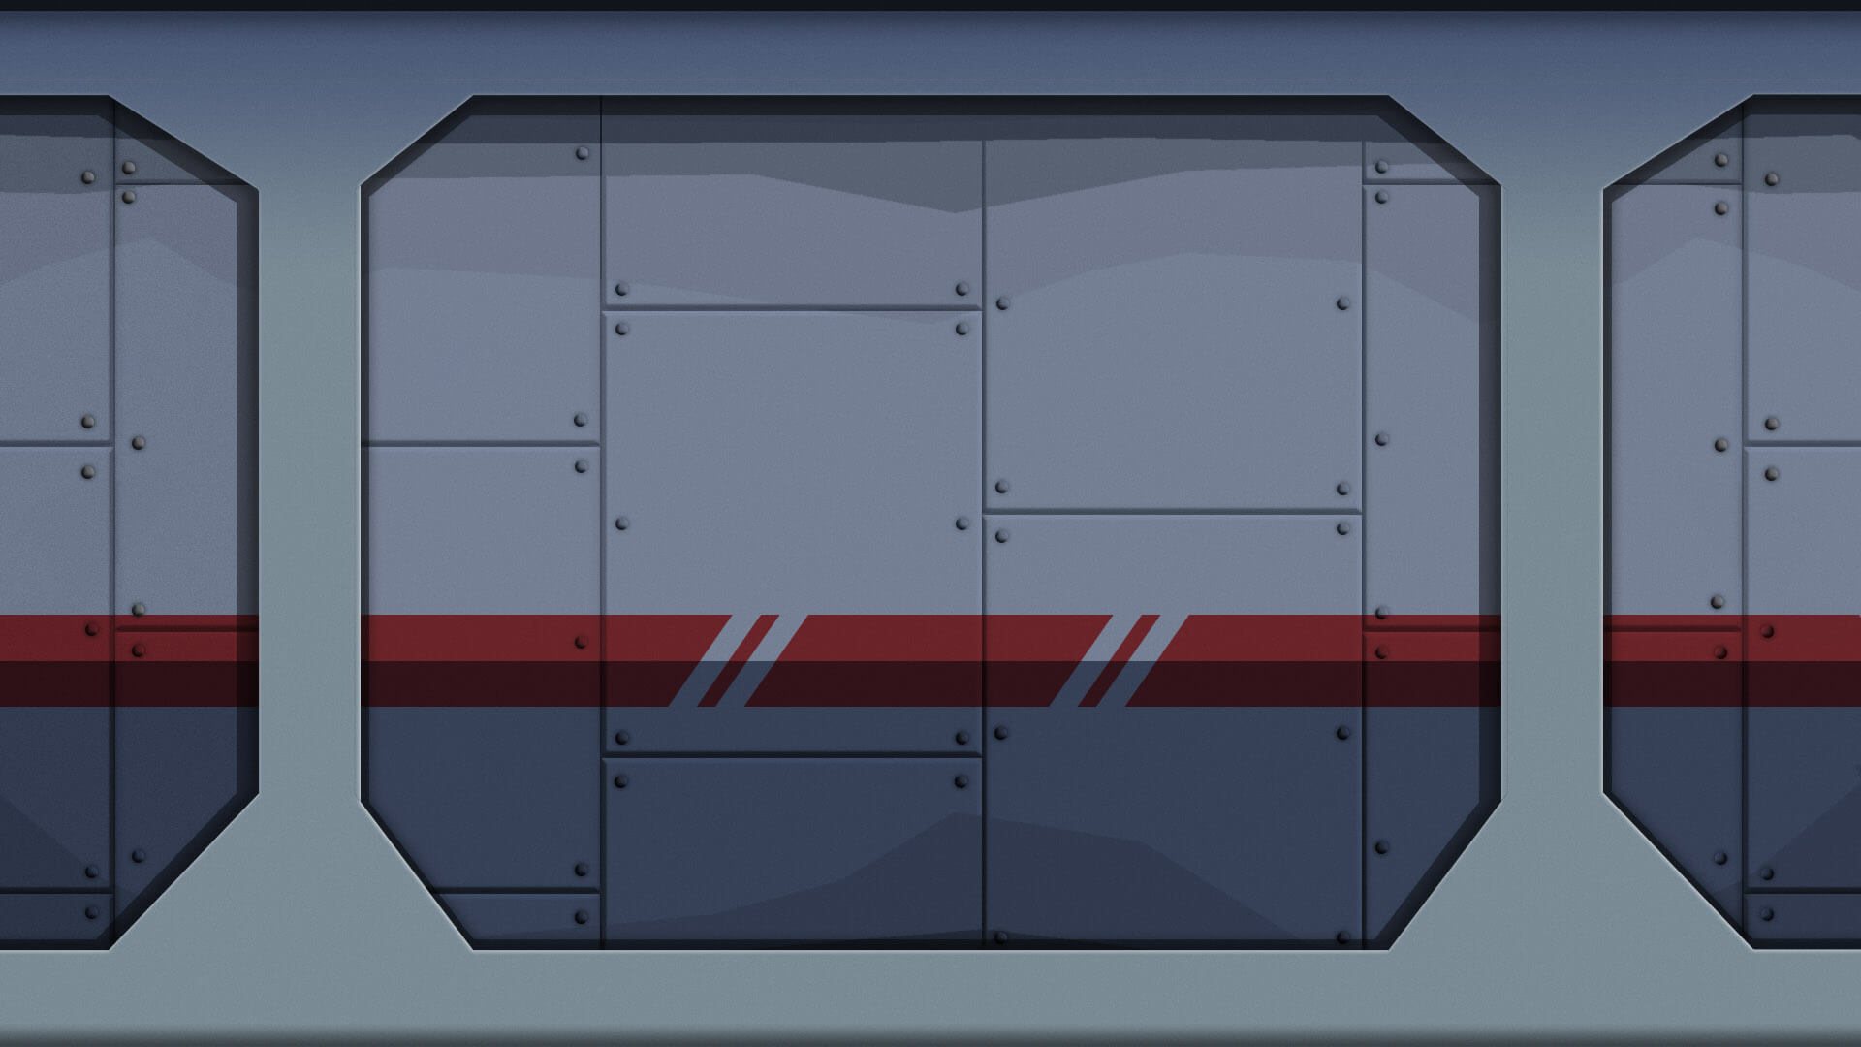

Level 1: Basement

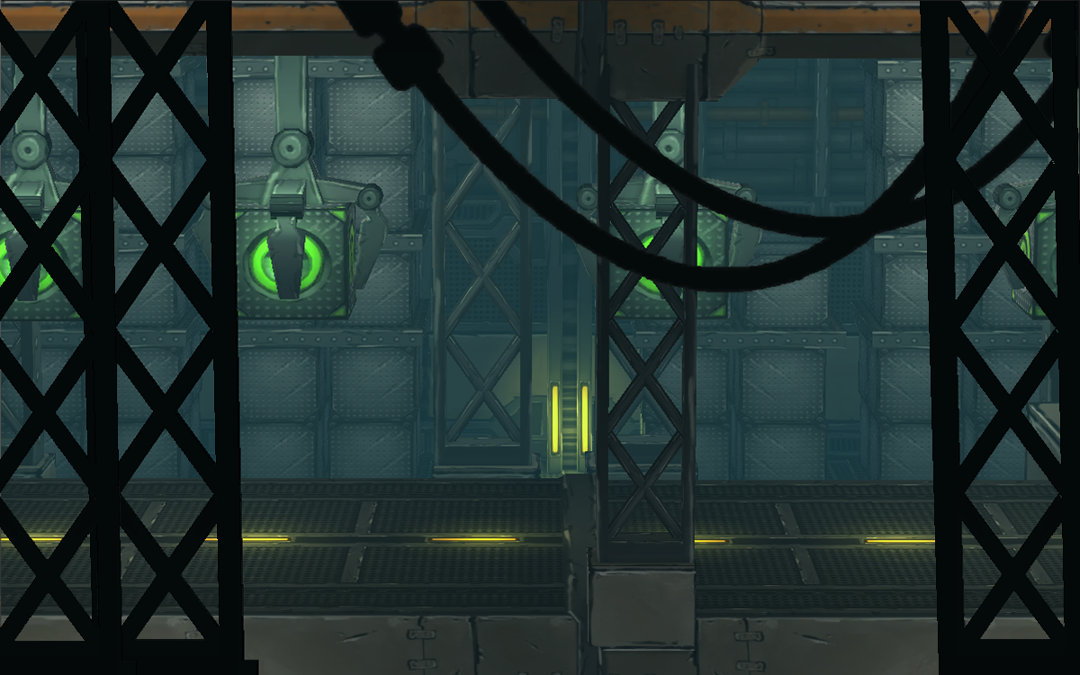level 2: storage room

level 3: laboratory



Energy bar sprite



Health bar



Iron man portrait

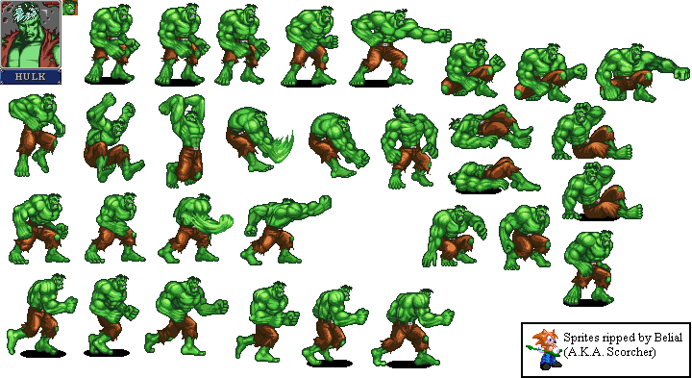

The Hulk sprite

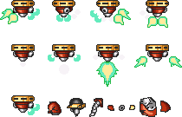

Flying enemy sprite



Explosion sprite



Heart sprite

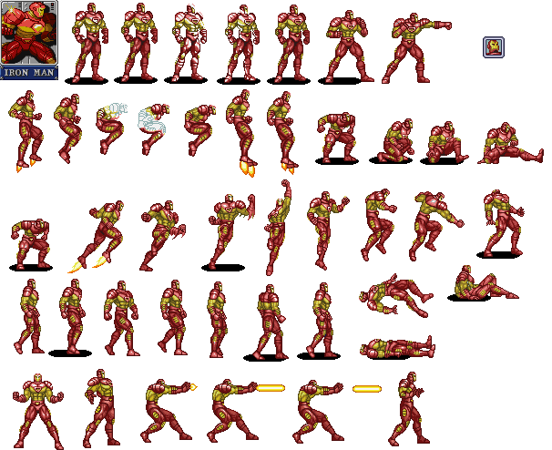

Iron Man sprite

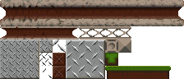

Platforms sprite



Door sprite

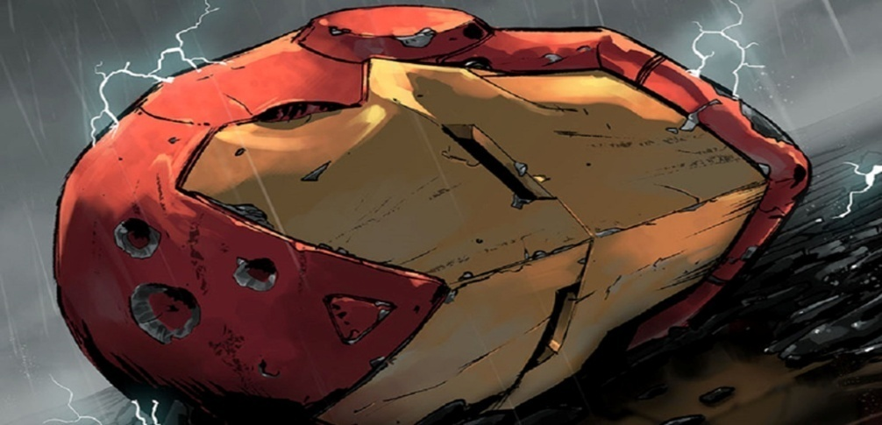

Game over background

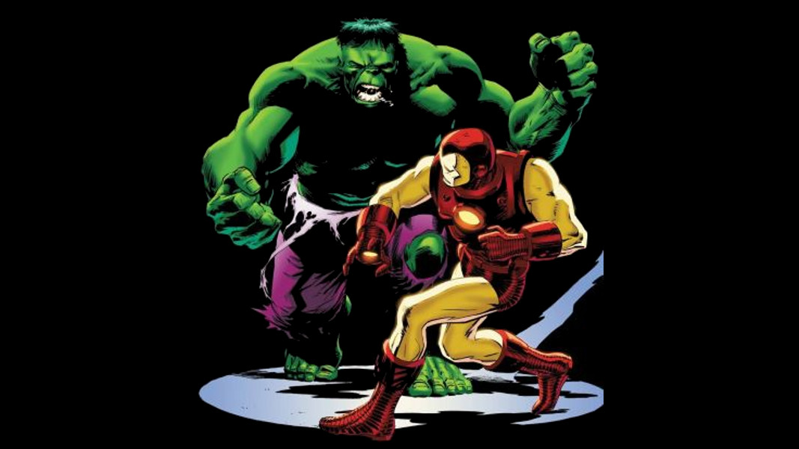

Win game background

# Future Features

* Final boss – WAR MARCHINE/ DR. DOOM
* New enemies – THUGS
* NEW LEVELS - CITY
* 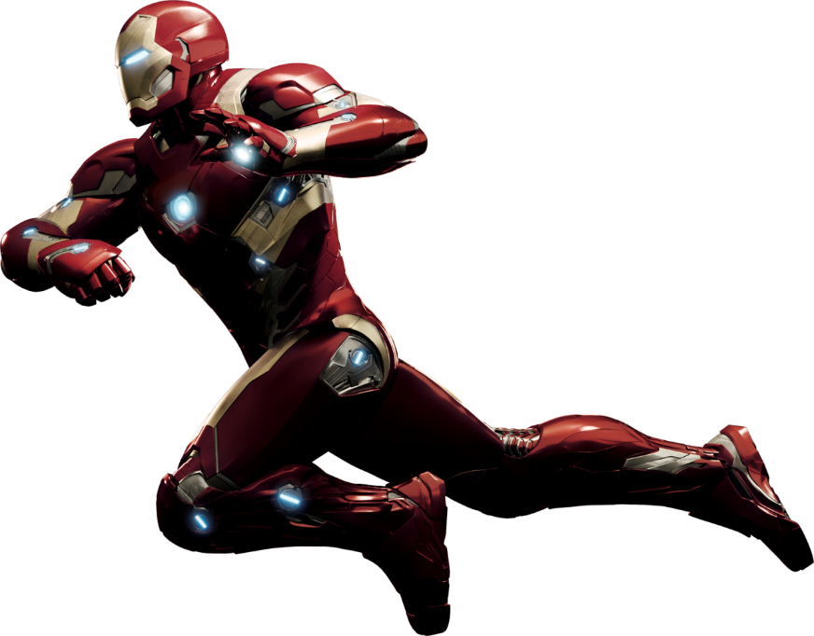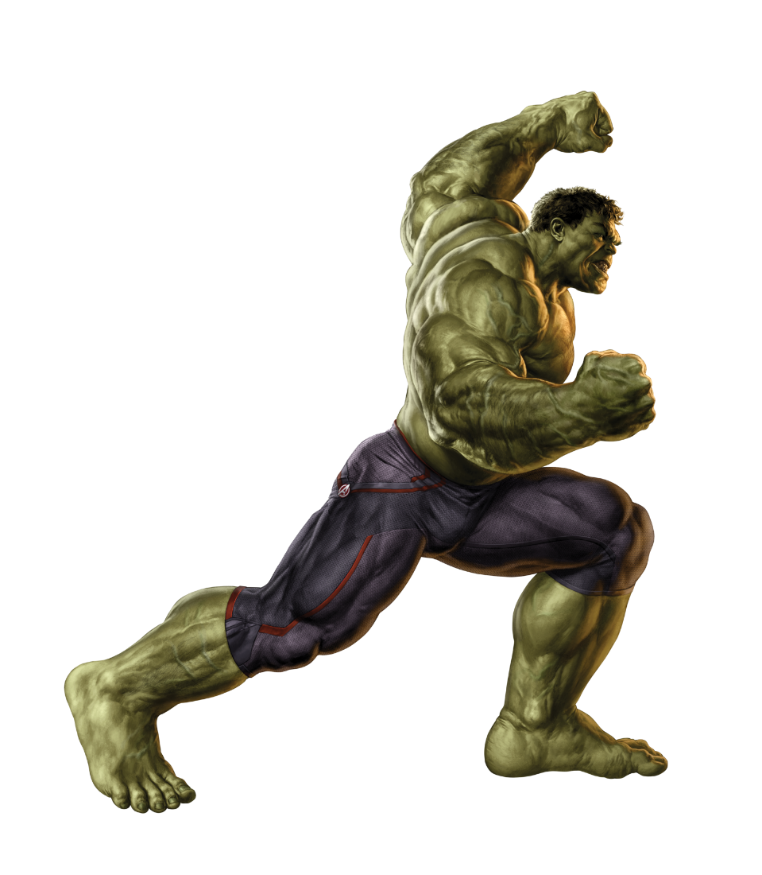Power-ups – INFINITE ENERGY